Date: 21 June 2023 | Supporting Communities  London Borough of Camden  4th Floor  5 Pancras Square  London  N1C 4AG  Tali.Sternfein@camden.gov.uk  Phone: 0207 974 4108 / 0797 3113 102  camden.gov.uk
Dear West Kentish Town Estate Resident

Re: Vacating Estate Parking on West Kentish Town Estate (WKTE)

As you will know from previous consultation, we are working to redevelop the whole of the West Kentish Town Estate (WKTE) and will not be re-providing Estate parking or garages on the new development. While the development will be “car-free”, meaning new residents will not be able to apply for a street parking permit. Existing WKTE residents will be entitled to apply for a replacement on their existing Street Parking Permit when they move into the new homes. No new car permits will be allocated once existing WKTE residents move into their new home in the Development .

I am writing now to give notice that the Council are cancelling all Estate Parking Friday 28 July 2023. This may come as a surprise to those who are in later phases, but all car spaces on WKTE need to be vacated by Friday 28 July 2023 in order to enable the construction of the new estate to start to take place. For instance, the car parks will be needed for the demolition and main contractor to install their welfare facilities for the early works they will be undertaking to deliver the Phase 1 blocks.

This means that any residents currently parking in any of the car parking spaces around the estate, as noted in the map below, will need to apply for a street parking permit and park in the Controlled Parking Zone (CPZ). A consultation on the CPZ has recently been undertaken by the Transport and Travel Planning Team and any changes that are recommended from this will be advertised by them in the local press and a letter posted to all addresses in the CPZ. Any changes proposed to be implemented would undergo a 6-month trial period.

To apply for a street parking permit please go to: https://www.camden.gov.uk/resident-parking-permits and click on ‘Apply for a resident parking permit’ to start the process. Please note you will need documentation to prove your WKTE address and vehicle ownership, plus the vehicle will need to be registered to your WKTE address. Please be sure to include all the correct documentation as the application fee is non-refundable. The CPZ permit costs depend on your vehicle’s emission and vary between £146.32 - £533.51 per annum. If you have any questions regarding Residents Street Permits please phone Contact Camden on 0207974 4444 choose option 4, then option 2, and hold for a Customer Service Operative.

When your Estate Parking permit is cancelled at the end of July, any remaining time left on the permit will be credited to your Camden rent account. If you are a Leaseholder you can request for any refund to be paid into your account by contacting Rentsupport@camden.gov.uk and providing your bank details.

If you have queries, please contact me on the details at the top of the page.

Kind regards,
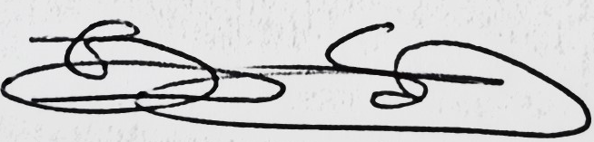
Tali Sternfein
Development Manager
WKTE Estate Parking locations map

