FAQs- Removing parking from WKTE to facilitate re-development
Q: Why do you need my car parking space?
A: The re-development of West Kentish Town Estate involves delivering new homes over eight phases of development. The first phase is across 4 sites. We will be working on all three garage sites- Wedmore, Langridge and Ashington garage sites, as well as the MUGA/ ball park, see plan on the last page. As such all spare parking spaces will be used for construction traffic, site set up, site facilities and/or play space for children.

Q: Why do you need my car parking space now/so soon?
A: The car parks will be needed for the demolition and main contractor to install their welfare facilities for the early works they will be undertaking to deliver the Phase 1 blocks. For these reasons all spare parking spaces will be used for construction traffic, site set up, site facilities and/or play space for children.

Q: I have more than 1 car, what do I do?
A: You can put more than one vehicle on your permit but only one vehicle will be covered by the parking permit at any one time and this must be activated via your online account. Failure to do so may result in your vehicle receiving a penalty charge notice (PCN). Your permit price will based on the vehicle with the highest emissions. For example, a permit that covers a vehicle in Tariff 1A and a vehicle in Tariff 4 will be priced at Tariff 4.
Street Permit costs 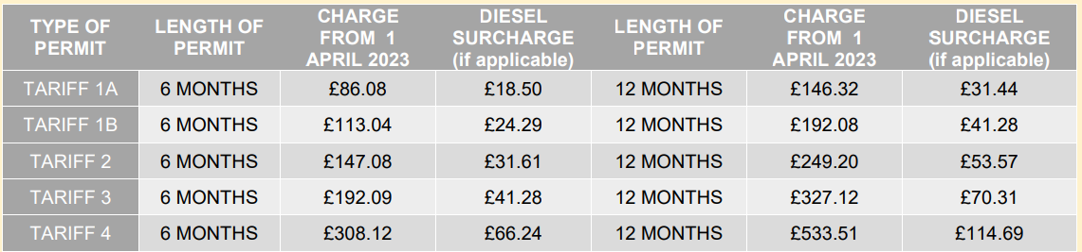
As noted in the letter to apply for a street parking permit please go to: https://www.camden.gov.uk/resident-parking-permits and click on ‘Apply for a resident parking permit’ to start the process.

Q: The permit hours are too short so I cannot get a parking space if I return outside of the 9-11am controlled hours.
A: A consultation on the CPZ has recently been undertaken by the Transport and Travel Planning Team and any changes that are recommended from this will be advertised in the local press and a letter posted to all addresses in the CPZ. Any changes proposed to be implemented would undergo a 6-month trial period during which any objections to the changes can be made and will be considered by the the Transport and Travel Planning team.
Q: Why is Street parking so expensive/ dependent on emissions?
A: Street parking costs (£146.32 - £533.51 per year depending on car emissions) are very comparable to Estate Parking and garage costs, which are also priced according to the vehicle’s emissions, see estate parking table below.
Estate Parking costs
Tenant/LH | 12 Months | Tariff 1 | Tariff 2 | Tariff 3 | Tariff 4
 | engine size | 0-1299 | 1300-1849 | 1850-2449 | 2450+
 | Co2 Rating levels | 0-150 | 151-185 | 186-224 | 225+
Hardstanding |  | £144.56 | £176.80 | £222.56 | £307.84
Partly Covered |  | £197.60 | £241.28 | £304.72 | £420.16
Covered |  | £310.96 | £381.16 | £481.00 | £663.00

Once you fill in the Street parking permit form with your car’s registration, the costs will be automatically calculated for you and you may find that Street Parking could even be cheaper.

Q: I am a disabled car user and need a space near my home. How can this be provided?
A: You can apply for a dedicated disabled bay through our safe travels team, whom we will contact for you. Please contact me on the details in the letter and/or come the our office at 104a Queens Crescent during open hours (10-5pm Monday and Wednesday, and 10-2pm on Friday) so we can provide you with an application form and the essential notes, and help you with completing this form.
The form needs to be completed and signed and stamped by the car user’s GP as well as the car user themselves. Documents that need to be provided are:
1. Copy of blue badge front and back
2. Copy of drivers licence
3. Copy of V5
4. Copy of documents to show you are in receipt of benefits i.e. PIP
If you have a carer/family member that is the designated driver, then the carer will need to prove they are registered living at the same address, so will need to provide their:
1. Copy of drivers licence
2. Proof of address such as utility bill or council tax statement
The completed forms should be brought to officers at 104a Queens Crescent for emailing to safetravel@camden.gov.uk

Phase 1 sites plan
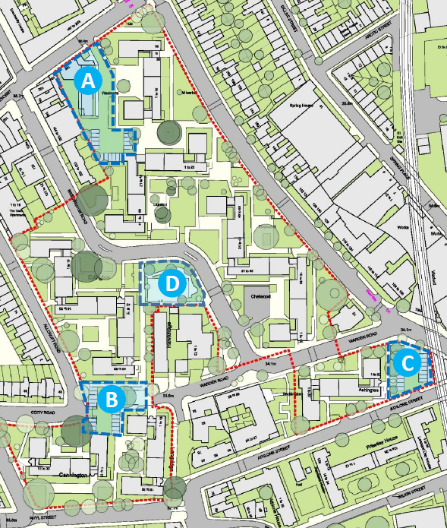
Site A- Wedmore garages and block
Site B- Langridge garages
Site C- Ashington garages
Site D- Multi Use Games Area (MUGA) / Ball court

